Device Setup: Gates

Circuit Diagram:
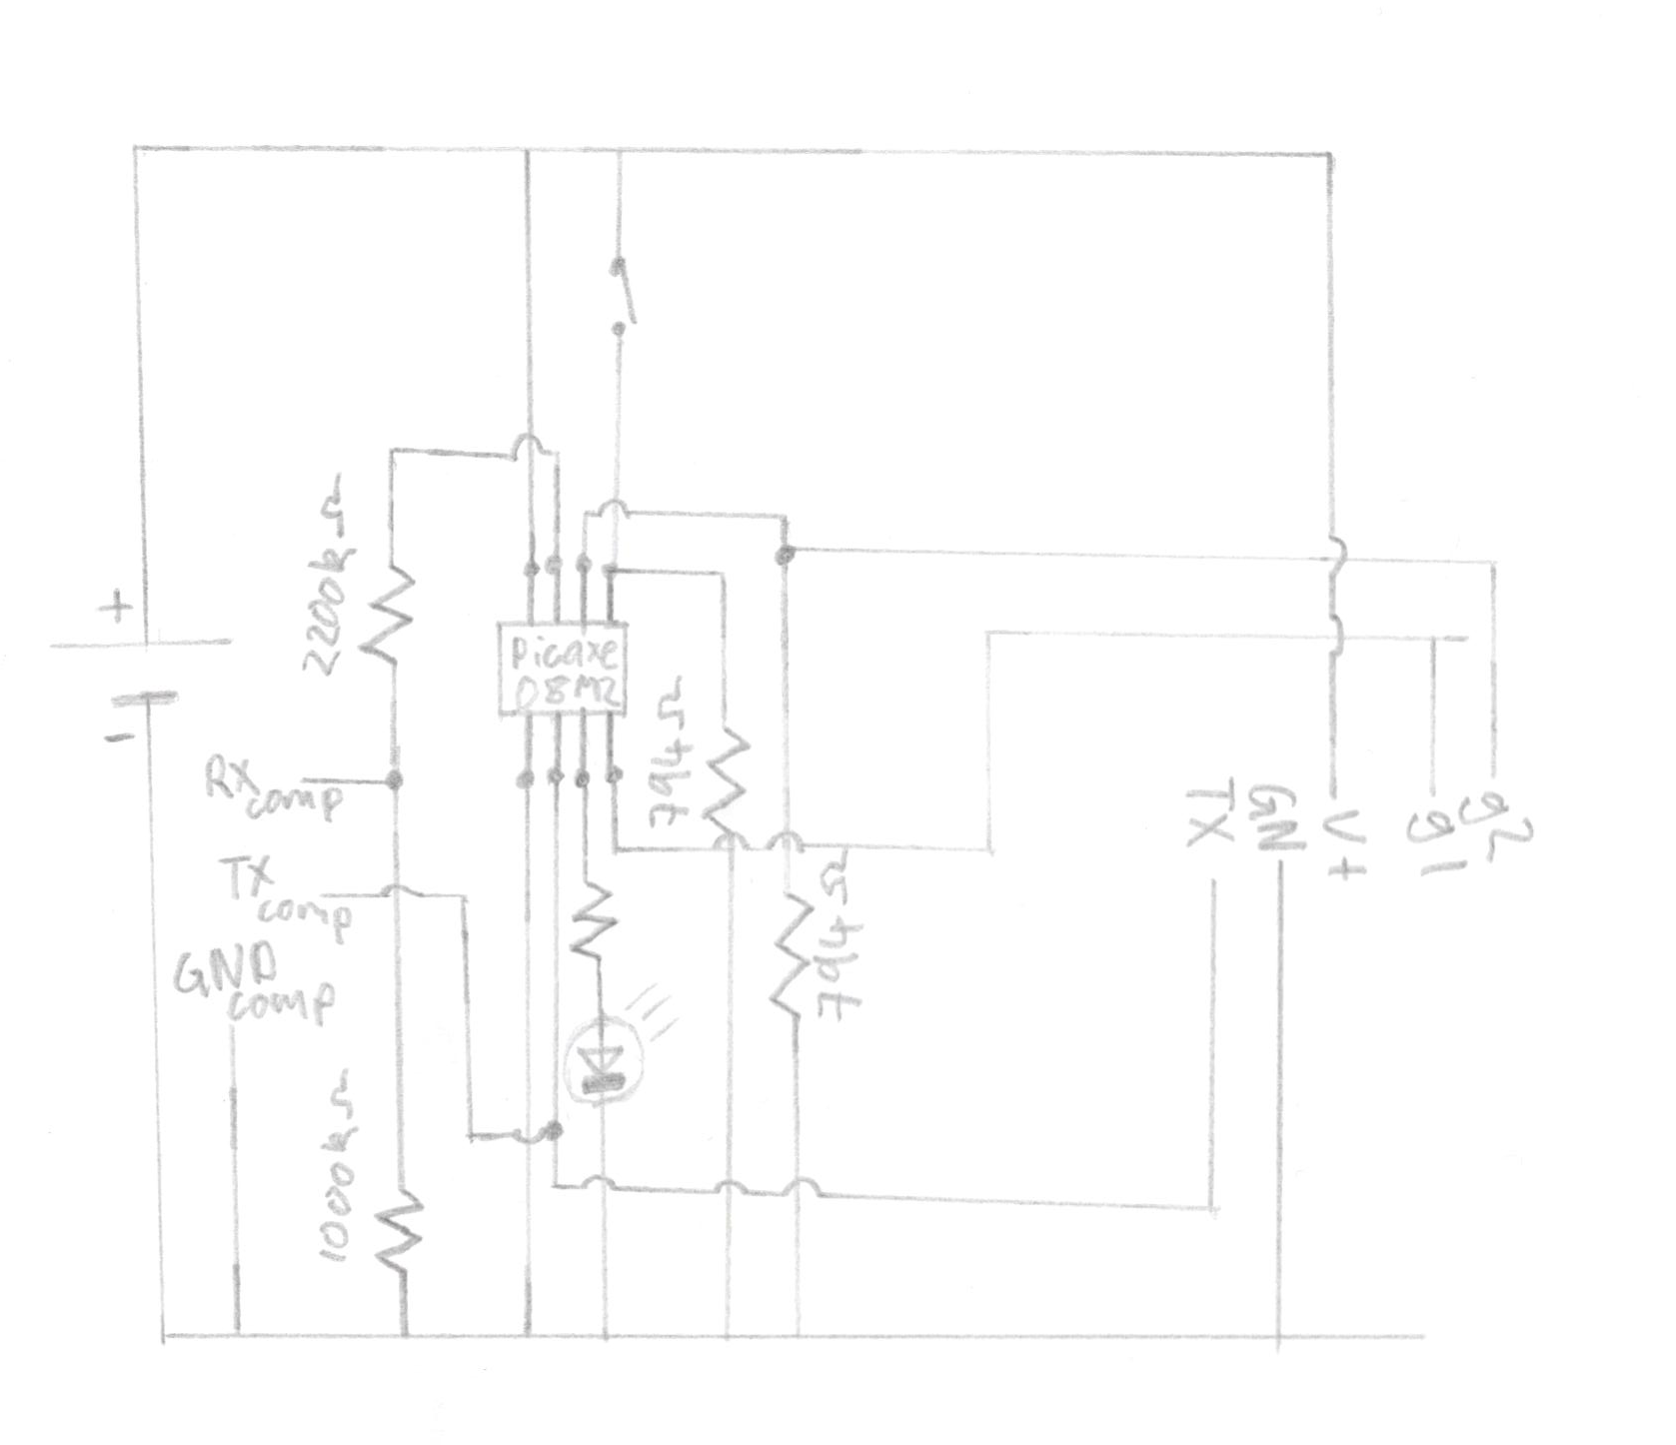
Installation.

Take the casing and mount it somewhere near the gate. Make sure it is somewhat sheltered.

Here is a simplified diagram of the circuit board inside, showing input output. (The far left socket is not used)
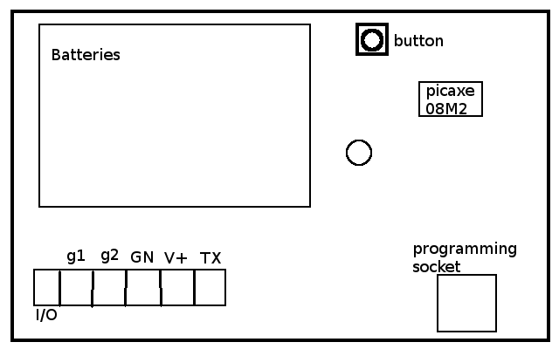
From this, connect a 3 core cable to GN, V+ and TX pins. Connect a 2 core cable to g1 and g2, then route all of these cables out the of the case.

The 3 core cable is for the transmitter, and the 2 core cable is for the gate sensor.

Connect the TX end of the 3 core cable to the DAT pin of the transmitter. Connect the GN core to the GND pin, and the V+ core to the VCC on the transmitter.

Connect the ANT pin of the transmitter to a 20cm wire, directed upwards, this is the antenna.
Connect g1 and g2 to the hall effect sensor to the two outside pins of the hall effect sensor. The middle pin doesn’t need to be connected to anything, and the direction doesn’t matter. Attach this to the gate post at the hinge end. Attach a Magnet opposite.

Setup and calibration
When you insert the batteries, the LED will start to flash once every 3 seconds. This means the device is in setup mode. Now close and latch the gate completely. Hold the button down until the led lights up again, then release the button. It should stay lit for 4 seconds. This means is taking a reading of the magnetic field. Once done it will return to flashing once every 3 seconds.
Now unlatch the gate and repeat. Now it will take a reading of the “closed but not latched” status. After it is done, start it’s normal program. In this program, it will read the gate every second, and flash the status light every 10 second as an indicator that it is working.
Ranges
Closed = Initial Closed reading +/- 5
Unlatched = Initial Unlatched reading +/- 5
Open = Everything outside the closed and unlatched ranges.

